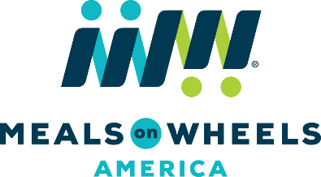

SAMPLE FACEBOOK POSTS
Use our sample Facebook posts to help share important Meals on Wheels messages with your friends, family, community and elected officials:

GENERAL MEALS ON WHEELS POSTS
Every day, millions of vulnerable seniors depend on nutritious meals and friendly visits delivered by Meals on Wheels volunteers – but millions more still need your help. Learn how you can advocate for your homebound neighbors today: www.mealsonwheelsamerica.org/advocate.

Nearly 9.7 million seniors in America face the threat of hunger. Meals on Wheels is there, delivering the nutrition and companionship that help seniors remain happy and healthy in the place they love most: home. www.mealsonwheelsamerica.org/facts

SUPPORT THE OLDER AMERICANS ACT
2.4 million seniors rely on Meals on Wheels, but millions more face hunger and isolation each day due to insufficient federal funding. Tell Congress to protect these vulnerable seniors by increasing funding for Meals on Wheels: www.mealsonwheelsamerica.org/emailcongress.

Meals on Wheels doesn’t just deliver nourishing food and companionship each day; it acts as a lifeline and family for millions of vulnerable seniors. Email your Members of Congress and urge them to support and protect our senior neighbors: www.mealsonwheelsamerica.org/emailcongress

Urge Congress to protect our country’s most at-risk seniors by increasing federal funding for the Older Americans Act, which supports Meals on Wheels programs nationwide. Take action by emailing your Members of Congress today: www.mealsonwheelsamerica.org/emailcongress.

