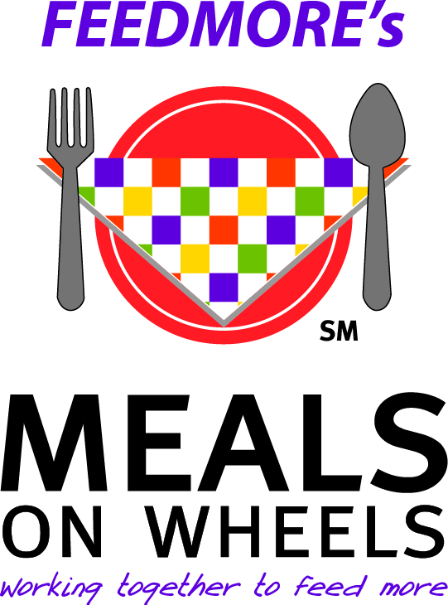
Meal Satisfaction Survey
Spring/Summer 2017

Dear Meal Recipient:

We are always trying to provide meals that are both healthy and delicious. Please take the time to complete this survey (both sides) and return to a Meals on Wheels volunteer or mail it to:
Meals on Wheels
1415 Rhoadmiller Street
Richmond, VA 23220

If you would like to be contacted about your comments please provide your name.

_________________________________________________________________
Please check the box indicating your rating for each question below: | Excellent | Good | Satisfactory | Poor
The overall appearance of your meal tray is…
The variety of foods you receive is…
The overall quality of the meals is…
Friendliness and service from staff is…
Friendliness from volunteers delivering meals

The meal portion sizes are… Too Small Too Large Just right

The taste/flavor of your food is... Too spicy Too bland Just right

Please tell us your age: _________ Are you male or female? Male Female
If you receive a second meal, have you been pleased with them?
Yes No N/A
What other foods would you like on the menu?_______________________________________
____________________________________________________________________________
What needs to be improved?_____________________________________________________
Please fill out the other side
MEAL SITE: AL CC/NK CF HS LS MI MV SR RM WEST

