Subject Line: Share the Love This Holiday Season!

Dear FIRST NAME,

I hope this message finds you warm and cozy as you prepare for Thanksgiving. Hard to believe the holiday season has already arrived!

I wanted to let you know about an exciting campaign that is near and dear to my organization’s heart: the Subaru Share the Love Event. In the past nine years, Subaru of America has donated over $12 million to the Meals on Wheels network—that’s the equivalent of more than 1.7 million meals to seniors across the country!

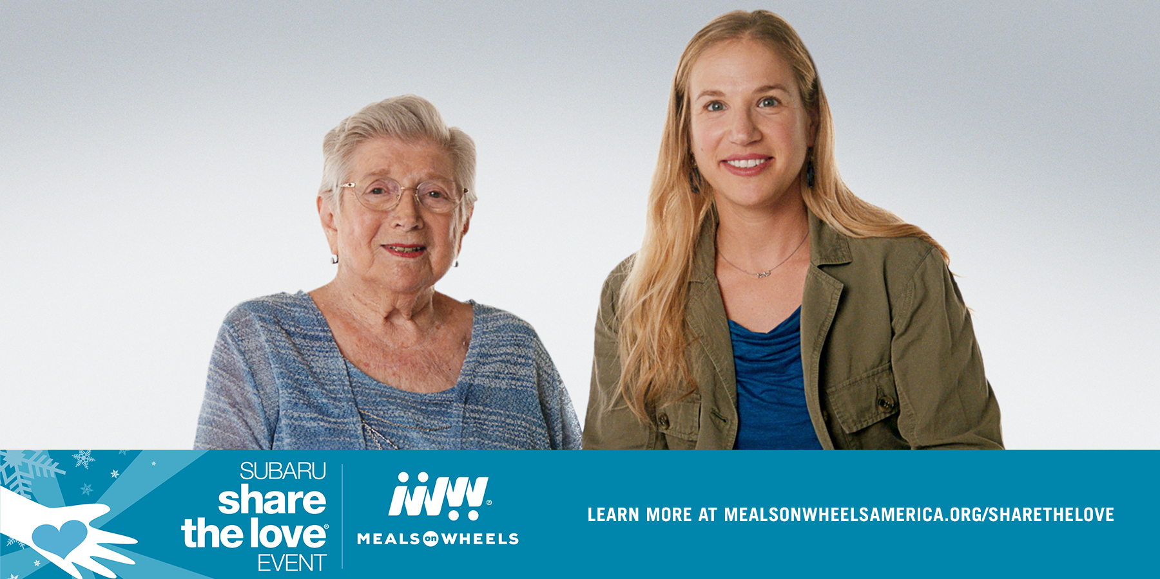

Here’s how it works: for every new Subaru vehicle leased or sold from November 16, 2017, through January 2, 2018, Subaru will donate $250 to the customer’s choice of participating charities. Meals on Wheels America is one of four national participating charities and has been since the inception of the Event. Through this campaign, as a Member of Meals on Wheels America, ORGANIZATION NAME will receive a share of the revenue earned in STATE.

If you’re in the market for a new car, please look into the Share the Love Event to learn more. If you’re not shopping for a new vehicle, you can still help by spreading the word to your family and friends. A few quick and easy ways to do that:

- Forward this email!
- Share our posts about Share the Love on Facebook: PROVIDE LINK. (You can also do this on twitter-- @HANDLE or Instagram-- @HANDLE)

I can’t thank you enough for your ongoing support of ORGANIZATION NAME. Both you and opportunities like this with Subaru make a meaningful difference in the lives of seniors.

Visit www.mealsonwheelsamerica.org/sharethelove to learn more.

Sincerely,

YOUR NAME

