Subject Line: Share the Love with Seniors Like Carol

Hi FIRST NAME,

For most of her life, Carol was an independent force of nature, working full-time, raising a special needs child and staying active in her church. But then she began to lose her sight. The woman so many relied on found herself unable to manage on her own.

She turned to Meals on Wheels. She got everything she expected and one incredible thing she didn’t – a new best friend. Amy had been volunteering for years but immediately felt a special connection with Carol.

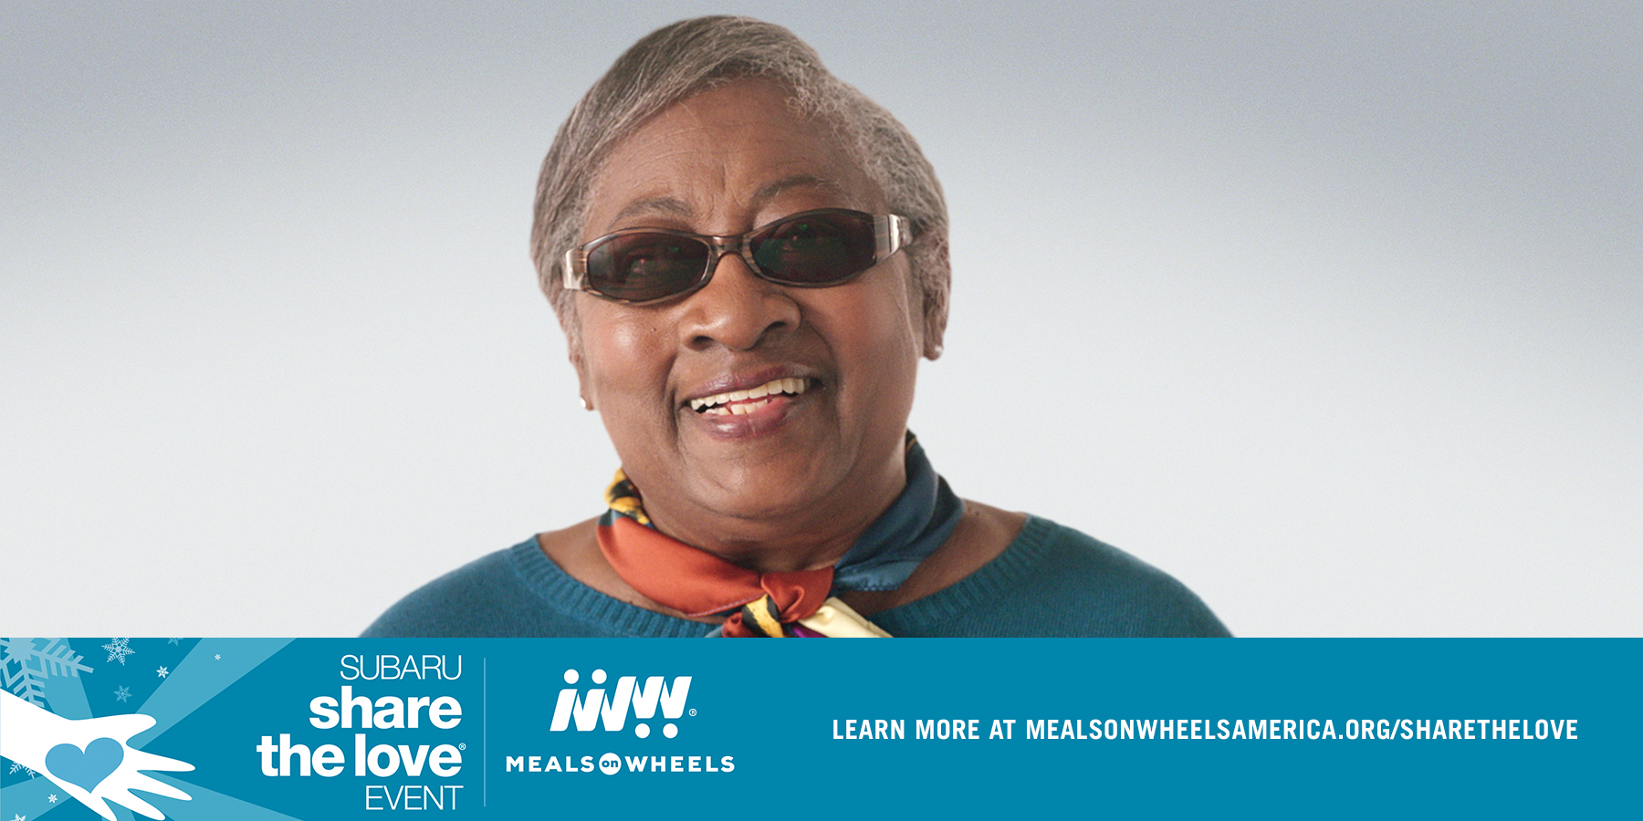

“She is one of those people who can completely inspire you”, Amy says. “I am lucky to have her in my life.” And Carol replies, “I think we were made for each other.”

Just as Carol depends on Amy, Meals on Wheels depends on generous people and companies to step up and support seniors. That’s why we’re incredibly grateful to one of Meals on Wheels’ longstanding and generous donors, Subaru of America.

Since its inception nine years ago, the Subaru Share the Love Event has raised millions of dollars and helped deliver more than 1.7 million meals to America’s seniors across the country.

In the Share the Love Event's tenth year, you can help that number grow. Between now and January 2, 2018, for every new Subaru vehicle sold or leased, Subaru will donate $250 to the customer's choice of participating charities, including Meals on Wheels America. These funds are then redirected to support the seniors served by PROGRAM NAME.

If you purchase a Subaru and select Meals on Wheels America, you will help ensure that seniors in COMMUNITY can remain healthy and form lasting relationships. You’re helping make more stories like Carol and Amy’s story a reality.

Thanks so much,

YOUR NAME

P.S. If you aren’t looking to purchase a new vehicle this holiday season, I hope you’ll still join me in thanking Subaru for its incredible support by passing this on to your friends and family.

Visit www.mealsonwheelsamerica.org/sharethelove to learn more.

